# Lab 8: People Array

Academic Honesty

* The work you turn in is to be your work, not copied from someone else, from the web, or generated by a program.
* Never allow anyone access to your files.
* Never give anyone your password.
* Never share your USB memory or email your files to anyone else.
* Never give anyone a printed copy of your file or an electronic copy.
* Never allow anyone to copy your work.

Purpose

This lab will let us practice looping through an array, finding an item in an array, and syncing multiple arrays together.

## Functionality

* Create 3 arrays
  + Array of attractions (Minimum 5)
  + Array of locations that correspond to those attractions
  + Array of colors
* Loop through the array of attractions and display the attraction names in the corresponding color
* Make the attractions display across the screen.
* You must use turtle.window_width() to help you make the names evenly appear across the screen.
* Make sure there is an underline from one name to the other.

## Sample Program

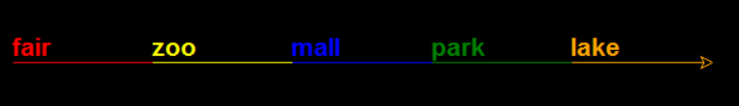

After the attractions are displayed, it will prompt you to enter an attraction:

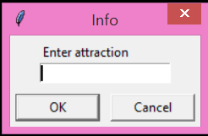

Once you enter a valid attraction, it will display the attraction location (from the array) directly below the attraction name, in the same color, e.g.

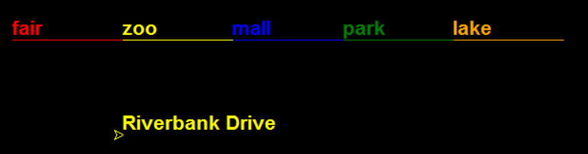

## Submitting your files

* Copy your .py file and move it to your X:\101Labs directory for grading.
* Make sure your file is named Lab8XY.py where XY are your initials
* Print your code, and submit it to your lab instructor at the beginning of your next lab class.

## Grade Breakdown

|  |  |
| --- | --- |
| **Points** | **Expectation** |
| 10% | Comments, listing program, your name, and explaining the code |
| 30% | Correctly setting up the for loop |
| 40% | Correctly draw names and space evenly across the screen. |
| 20% | Create underline between names |